A Capstone Project by

Michael Angelo A. Angeles
Zurich M. Cabañelez
Elton John K. Muralla
Jesse Emannuel L. Pepito

Submitted to the Information Technology Department, College of Technologies
Bukidnon State University

In Partial Fulfillment
of the Requirements for the Degree
<Degree>

<Month and year of degree conferral, not date of submission>

APPROVAL SHEET
This capstone project Vehicles in Yellow Box Zone Monitoring System Using AI-Based Camera Detection, prepared and submitted by Michael Angelo A. Angeles, Zurich M. Cabañelez, Elton John K. Muralla, Jesse Emannuel L. Pepito in partial fulfillment of the requirements for the degree <Degree> is hereby accepted.

PETER JOSEPH G. RABANES
Capstone Project Adviser
DR. ROZANNE TUESDAY G. FLORES
Chair, Defense Panel
ROANNE ZOE M. CAYANAN | ANNA ROSE C. TAN
Panel Member | Panel Member

Accepted and approved for the conferral of the degree <Degree>.

SALES G. ARIBE JR., DIT MARILOU O. ESPINA, DIT
Department Head, Information Technology Dean, College of Technologies

ACKNOWLEDGMENTS
The road to this point in your studies couldn’t have been travelled alone. Along the way, someone somewhere helped you. This is your chance to thank them.
By the way, exercise the liberty to be personal to reflect the sincerity of your gratitude.

TABLE OF CONTENTS
APPROVAL SHEET 2
ACKNOWLEDGMENTS 3
TABLE OF CONTENTS 4
LIST OF TABLES 6
LIST OF FIGURES 7

1 INTRODUCTION 8
1.1 Background of the Study 8
1.2 Objectives of the Study 11
1.3 Significance of the Study 12
1.4 Scope and Delimitations 13
2 REVIEW OF RELATED LITERATURE 14
2.1 Related Literature 14
2.2 Related System 18
2.3 Concept of the Study 21
2.4 Definition of Terms 22
3 METHODOLOGY 24
3.1 Materials 24
3.1.1 Software 24
3.1.2 Hardware 25
3.1.3 Data 25
3.2 Methods 26
3.2.1 Research Design 26
3.2.2 Process Model 27
3.2.3 Procedures for the different phases 28
3.2.6 Evaluation 35

LIST OF TABLES
Table 1-1. Summary of reviewed studies on AI-based traffic monitoring systems. 17
Table 2-1. Comparison of Existing System. 18

LIST OF FIGURES
Figure 1-1. Conceptual framework of the AI-Powered Vehicle Yellow Box Monitoring System 24
Figure 2-1. Process Model Diagram 29
Figure 3-1. Use Case Diagram 31
Figure 4-1. Data Flow Diagram 32
Figure 5-1. System Architecture 32
Figure 6-1. Database Schema 33

INTRODUCTION
This section provides the background and rationale for the study, identifies the research problem, states the objectives, and discusses the significance and scope of the proposed AI-based Vehicles monitoring system.

Background of the Study
Traffic congestion and violations of road regulations remain significant challenges in many urban areas across the Philippines. With the continuous increase in vehicle volume, local government units (LGUs) struggle to maintain efficient traffic flow due to limited manpower and a heavy reliance on manual monitoring and enforcement methods (Department of Transportation [DOTr], 2023). Public transport vehicles, are frequently observed committing traffic violations such as stopping or waiting for passengers within yellow box zones, prolonged loading and unloading at intersections, obstructing pedestrian crossings, and occupying restricted road spaces beyond allowable stop times. These improper road behaviors disrupt traffic movement, block intersecting lanes, and contribute to vehicle queuing, travel delays, and reduced road efficiency, especially in high-traffic intersections (Ho et al., 2019; Bhavsar et al., 2023; Rathore et al., 2021). In the context of Malaybalay City, Preliminary observations conducted during peak hours reveal that Vehicles related stopping violations occur repeatedly within short monitoring periods, with multiple instances can be seen daily at designated yellow box zones.
Recent advancements in Artificial Intelligence (AI) and computer vision have enabled the development of automated traffic monitoring systems capable of analyzing vehicle behavior through camera-based input. Studies have shown that AI-based systems using deep learning models such as Convolutional Neural Networks (CNNs) and You Only Look Once (YOLO) can effectively detect and classify vehicles in real time, offering higher accuracy and consistency compared to traditional observation-based methods (Valdivieso Tituana et al., 2022; Basheer Ahmed et al., 2023). These technologies allow traffic authorities to collect objective, data-driven insights that support improved enforcement and decision-making.
In the context of Malaybalay City, Bukidnon, the Traffic Management Center (TMC) currently relies on a combination of traffic personnel and limited Closed-Circuit Television (CCTV) monitoring to oversee road activity. However, this approach restricts coverage and real-time response, particularly during peak hours when traffic volume is high (Malaybalay City Information Office, 2024). The absence of intelligent monitoring tools highlights the need for a system that can automatically observe Vehicles activity and provide timely visual and recorded information to assist traffic authorities.
Therefore, there is a need for a technology-assisted approach that can support traffic monitoring operations in Malaybalay City by addressing recurring Vehicles-related violations in yellow box zones. Integrating artificial intelligence and camera-based detection into the existing CCTV and traffic surveillance infrastructure may help improve monitoring efficiency, promote better compliance with traffic regulations, and support local traffic management and urban mobility development efforts of the Malaybalay City local government. Such an approach aligns with the city’s ongoing efforts to improve traffic flow, strengthen enforcement capability, and modernize traffic operations through technology-driven solutions (Bhavsar et al., 2023; Rathore et al., 2021).
Statement of the Problem
Despite the implementation of traffic regulations and the deployment of monitoring personnel, improper vehicles behavior continues to be a persistent contributor to traffic congestion in Malaybalay City, particularly in yellow box zones located at busy intersections. Frequent violations such as prolonged stopping, loading and unloading within restricted zones, and obstruction of intersecting lanes disrupt traffic flow, delay commuters, and reduce overall road efficiency, especially during peak hours.
The Traffic Management Center (TMC) currently relies on manual enforcement and limited CCTV monitoring, which constrains continuous observation, accurate documentation, and real-time response. These limitations make it difficult to consistently detect violations, objectively validate infractions, and promptly address congestion caused by recurring vehicles stoppages. As traffic volume continues to increase, these challenges place additional strain on enforcement personnel and hinder the city’s ability to manage traffic effectively.
Without an automated and intelligent monitoring mechanism, vehicle-related violations are likely to persist, resulting in recurring congestion, inefficient enforcement, and limited availability of reliable data to support traffic planning and policy formulation. This situation underscores the need for a technology-driven solution that can provide continuous, objective, and real-time monitoring of vehicles activity to support traffic management and enforcement operations in Malaybalay City.
This study seeks to address the following question:
How can an AI-based system be developed to automatically monitor vehicle activity using camera input and provide real-time data to support traffic management and enforcement in Malaybalay City?

Objectives of the Study
The main goal of this study is to enhance traffic management in Malaybalay City by developing a system capable of monitoring vehicle activity in yellow box zones and providing actionable information to support enforcement operations.
Specifically, the study aims to:
- Enable real-time detection and monitoring of vehicle entering and stopping in yellow box zones.
- Automate the recording of vehicle stop times and generate alerts when violations occur.
- Provide the Traffic Management Center (TMC) with an interactive dashboard to review violations, access historical data, and support data-driven decision-making.
- Evaluate the system’s effectiveness in terms of monitoring accuracy, reliability, and usability under various traffic conditions.

Significance of the Study
This study will be significant to the commuting public of Malaybalay City, particularly daily passengers, students, and workers, because it aims to reduce delays and improve travel reliability by minimizing prolonged vehicle stoppages in yellow box zones, thereby enhancing overall commuter experience and time efficiency.
For vehicle drivers and operators, the AI-powered monitoring system will provide clearer rules of engagement and objective evidence for deciding violations, which can promote fairer enforcement, encourage compliance with traffic regulations, and foster a more disciplined transport environment.
The Traffic Management Center (TMC) of Malaybalay City will gain a practical and scalable tool for real-time monitoring, automated reporting, and prioritized resource allocation, enabling officers to focus enforcement efforts where they are most needed and make faster, data-driven decisions.
Local government units and policymakers will benefit from accurate, longitudinal traffic data produced by the system, which can inform future policy-making, traffic planning, zoning decisions, and public transport improvements.
Finally, future researchers and system developers will be able to use this project as a foundation for further studies on AI-based monitoring systems and their adaptation to other local government applications.

Scope and Delimitations
This study focuses on the design and development of an AI-based monitoring system intended to assist the Traffic Management Center (TMC) of Malaybalay City. The system processes video input from fixed cameras installed at selected road locations to detect and monitor vehicle activity.
The scope of the study includes system development, testing, and evaluation under controlled and field-simulated conditions. A graphical dashboard interface is developed to allow authorized personnel to view monitoring results and recorded data.
The delimitations of the study include its focus on vehicles as the primary monitored vehicle type and its limitation to visual monitoring through camera input. Other traffic violations, such as speeding or counterflowing, are beyond the scope of this research and may be considered for future system enhancement.

REVIEW OF RELATED LITERATURE

Related Literature
This section examines previous studies and existing systems in traffic monitoring, AI-based vehicle detection, and camera-based surveillance to identify gaps addressed by the proposed system.
Traffic Monitoring
Traffic monitoring is a critical component of urban traffic management, as it enables authorities to observe vehicle movement, detect violations, and implement timely enforcement actions. Traditional traffic monitoring in many Philippine cities relies heavily on manual observation by traffic enforcers and limited CCTV coverage, which restricts continuous monitoring and real-time response, especially during peak traffic periods (Department of Transportation [DOTr], 2023).
Recent studies have emphasized the role of automated traffic monitoring systems in improving enforcement efficiency and reducing human error. Ho et al. (2019) demonstrated that camera-based roadside occupation surveillance systems can effectively detect vehicles occupying restricted road spaces and intersections. Similarly, Rathore et al. (2021) showed that intelligent traffic monitoring systems integrating computer vision can provide real-time detection of traffic violations, enabling faster response and more consistent enforcement. These findings highlight the need for automated traffic monitoring solutions to address recurring issues such as improper stopping and intersection blockage.
Artificial Intelligence in Traffic Management
Artificial Intelligence has been widely applied in traffic management to analyze complex traffic patterns, automate vehicle detection, and support decision-making processes. Valdivieso Tituana et al. (2022) reviewed various AI-based traffic analysis methods and found that deep learning models, particularly Convolutional Neural Networks (CNNs), significantly improve vehicle detection accuracy compared to traditional image processing techniques.
Basheer Ahmed et al. (2023) further demonstrated that AI-based systems using YOLO models can accurately detect and classify vehicles in real time under diverse traffic and environmental conditions. These AI-driven approaches enable traffic authorities to shift from reactive to proactive enforcement by providing continuous, data-driven monitoring. However, most existing AI-based traffic systems focus on traffic flow analysis and incident detection rather than monitoring compliance with zone-specific regulations such as yellow box intersections.

Camera-Based Detection Technologies
Camera-based detection technologies form the foundation of modern AI-powered traffic monitoring systems. Fixed CCTV cameras combined with computer vision algorithms allow continuous observation of road activity without direct human intervention. Studies by Bhavsar et al. (2023) demonstrated that vision-based systems can reliably detect traffic violations such as improper stopping, lane obstruction, and road occupancy using video footage.
Tan and Kieu (2023) introduced TRAMON, an automated traffic monitoring system capable of handling mixed and unstructured traffic environments common in developing regions. Meanwhile, Rezaei et al. (2022) proposed Traffic-Net, which utilized deep learning and depth estimation to track vehicles using a single camera. Although these systems achieved high detection and tracking accuracy, they primarily focused on movement and spatial analysis rather than measuring stop-time duration within restricted zones. This limitation highlights the need for camera-based systems that incorporate temporal analysis to support zone-specific enforcement.

Overall, existing literature confirms that AI-based camera detection systems are effective for vehicle monitoring and traffic regulation. However, limited studies focus on vehicle monitoring within yellow box zones, particularly in small-city settings such as Malaybalay City. This research addresses this gap by developing a Vehicle Yellow Box Zone Monitoring System Using AI-Based Camera Detection, tailored to local traffic conditions and enforcement needs.

Table 1-1. Summary of reviewed studies on AI-based traffic monitoring system
Author/Year | Study | Method | Findings | Gaps
(Valdivieso Tituana et al., 2022) | Vehicle detection and counting | CNNs, YOLO, Faster R-CNN | High detection accuracy | Lacked behavioral analysis
(Ho et al., 2019) | Computer vision-based roadside occupation surveillance | Region-of-interest detection, fixed cameras | Automated monitoring reduced human error | Focused only on static roadside occupation; no dynamic stop-time analysis
(Basheer Ahmed et al., 2023) | Traffic incident detection | CNN, YOLOv5 | Accurate anomaly detection | Focused on movement-based events
(Bhavsar et al., 2023) | Violation detection via UAV | Object tracking, UAV imaging | Identified road violations | Limited to single case study
(Nocua M et al., 2025) | Edge AI monitoring | YOLOv5 on embedded GPU | Low-cost real-time detection | No behavioral metrics
(Rathore et al., 2021) | Fog-based violation detection | IoT + Computer Vision | Real-time detection via fog nodes | Lacked focus on dwell-time
(Tan & Kieu, 2023) | Mixed traffic analysis | Multi-object tracking | Effective in unstructured traffic | No stop-time monitoring
(Rezaei et al., 2022) | 3D Tracking | Depth estimation models | Accurate localization | No compliance analysis

Related System

Table 2.1 - Comparison of Existing System.
System / Study | Vehicle Detection | AI-Based Processing | Camera-Based Input | Real-Time Monitoring | Stop-Time Measurement
Traffic-Net (Rezaei et al., 2022) | ✓ | ✓ | ✓ | ✓ | ✗
TRAMON (Tan & Kieu, 2023) | ✓ | ✓ | ✓ | ✓ | ✗
Smart Traffic Control (Rathore et al., 2021) | ✓ | ✓ | ✓ | ✓ | ✗
Vision-Based Violation Detection (Bhavsar et al., 2023) | ✓ | ✓ | ✓ | ✓ | ✗
Edge AI Traffic Monitoring (Nocua et al., 2025) | ✓ | ✓ | ✓ | ✓ | ✗
Proposed System | ✓ | ✓ | ✓ | ✓ | ✓

Table 2-2 presents a comparative analysis of existing AI-based traffic monitoring systems and the proposed Vehicle Yellow Box Zone Monitoring System Using AI-Based Camera Detection. The table highlights key functional features, including vehicle detection, artificial intelligence–based processing, camera-based input, real-time monitoring, stop-time measurement, yellow box zone monitoring, and focus on public transport vehicles. Check marks (✓) indicate the presence of a feature in a system, while crosses (✗) indicate its absence or lack of emphasis in the reviewed studies.
The comparison shows that while most existing systems successfully implement AI-driven vehicle detection and real-time camera-based monitoring, they primarily focus on general traffic flow, incident detection, or vehicle tracking. In contrast, stop-time measurement, zone-specific enforcement, and monitoring of public transport vehicles, particularly vehicles, are not explicitly addressed in these systems. The proposed system integrates these missing features, thereby addressing a critical gap in localized traffic monitoring and enforcement needs in Malaybalay City.

Research Gap
While prior research demonstrates the effectiveness of AI and camera-based traffic monitoring systems, there is a clear gap in real-time enforcement of yellow box zones and monitoring of m vehicles in small-city contexts. Existing studies do not focus on measuring stop duration, automated violation alerts, or evidence collection for public transport vehicles, which are essential for effective traffic management in Malaybalay City. This study addresses this gap by developing a system that integrates AI-based vehicle detection, stop-time tracking, and a dashboard interface for the Traffic Management Center (TMC), providing timely, objective, and actionable information to support traffic enforcement and reduce congestion caused by vehicle violations.

2.3 Concept of the Study

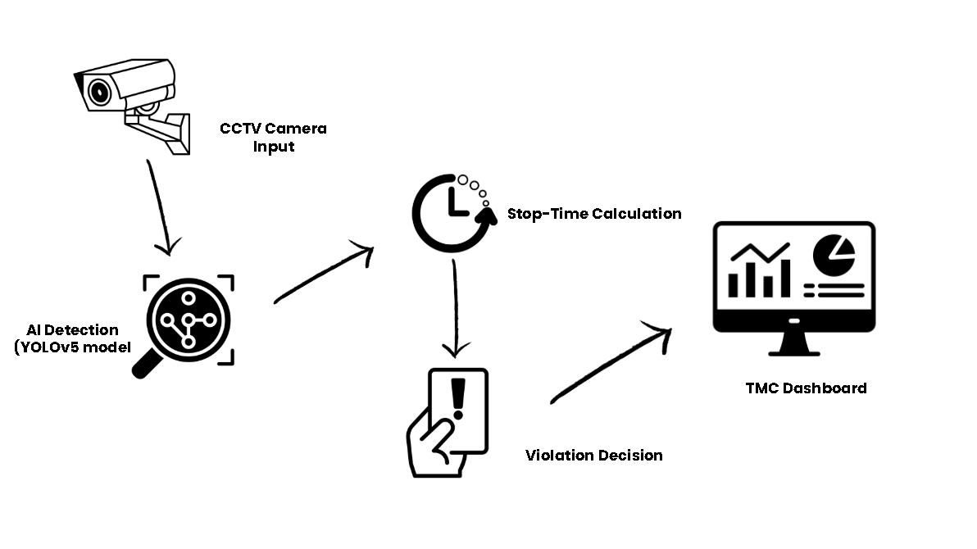
Figure 1-1. Conceptual framework of the AI-Powered Vehicle Yellow Box Monitoring System

The conceptual framework of the study illustrates how the AI-Powered Vehicle Yellow Box Monitoring System processes visual data to support traffic enforcement. CCTV cameras installed at selected intersections capture real-time video footage, which serves as the system’s primary input. The video stream is processed by a deep learning-based object detection model (YOLOv5) to identify and classify vehicles within the yellow box zone.

Once a vehicle is detected, the system applies multi-object tracking to continuously monitor its movement and calculate its stop-time duration. If the vehicle remains stationary beyond the allowable limit, the system triggers a violation event.

All violation data, including stop-time duration, timestamp, location, and visual evidence, are stored in the system database and transmitted to the Traffic Management Center (TMC) dashboard. Authorized TMC personnel can then review, verify, and act upon the recorded violations, forming a closed-loop, AI-assisted traffic monitoring and decision-support system

2.4 Definition of Terms
Artificial Intelligence (AI) — the simulation of human intelligence in machines programmed to perform tasks such as learning, reasoning, and problem-solving.
Computer Vision — A field of AI that enables computers to interpret and process visual information from digital images or videos.
Convolutional Neural Network (CNN) — a deep learning architecture primarily used for image recognition and object detection tasks.
YOLO (You Only Look Once) — a real-time object detection algorithm capable of identifying multiple objects within an image or video frame.
Traffic Management Center (TMC) — the local government office responsible for monitoring and enforcing traffic regulations.
Yellow Box Zone — A marked intersection area where vehicles are prohibited from stopping to prevent traffic obstruction.
Stop-Time Monitoring — the process of measuring how long a vehicle remains stationary in a designated area.
Edge AI — the use of artificial intelligence algorithms on local devices or networks near the data source, minimizing latency and bandwidth use.

METHODOLOGY
This section describes the materials, data sources, research design, and procedures used to develop the AI-based vehicle yellow box monitoring system.

Materials

Software
The proposed system will be developed using the following software tools:
- Python 3.10 – primary programming language for AI and computer vision development
- OpenCV – video processing, frame extraction, and image enhancement
- YOLOv5 (PyTorch-based) – real-time vehicle detection and classification
- DeepSORT / ByteTrack – multi-object tracking for vehicle identity preservation
- React & Node.js – backend services and web-based dashboard development
- MongoDB – storage of violation records, plate numbers, timestamps, and images
- SQLite – for temporary database when developing
- LabelImg – dataset annotation for training the detection model
- Google Colab – GPU-accelerated AI model training and fine-tuning

Hardware
The hardware setup will simulate a real-world monitoring environment:
High-definition CCTV Camera (1080p, 30 fps) – for capturing vehicle behavior at intersections and yellow box zone.
Desktop Computer (Intel i7, 16GB RAM, NVIDIA GTX 1660 GPU) – for model training and testing.
Network Router and Ethernet Connection – to link CCTV input to the AI system.
Monitor Display (for TMC Dashboard) – for TMC officers to review detected violations.

Data
The dataset will consist of real-world traffic footage collected from Malaybalay City intersections.
Source of Data: The dataset used in this study will consist of real-world traffic footage collected from selected intersections in Malaybalay City, Bukidnon, particularly those with yellow box zones. The sources include:
- Traffic Management Center (TMC) CCTV Footage – video recordings from existing traffic cameras installed at key intersections.
- Supplementary Public Datasets – open-source traffic video datasets available online for training purposes to augment real-world data.
- Supplementary open-source traffic datasets for training and validation.

Type of Data: Video frames and annotated images of vehicles, tricycles, and cars.
Year of Acquisition: 2025 – 2026
Data Volume: Around 5 minutes of footage TMC allowed us to use their CCTV video.
Data Processing: Manual labeling using LabelImg for YOLOv5 training.

Methods

Research Design
This study will use a Developmental Research Design, focusing on the design, implementation, and evaluation of an AI-based system prototype. The research will follow the Waterfall Model, including sequential phases: requirements analysis, system design, implementation, testing, and evaluation.

Process Model 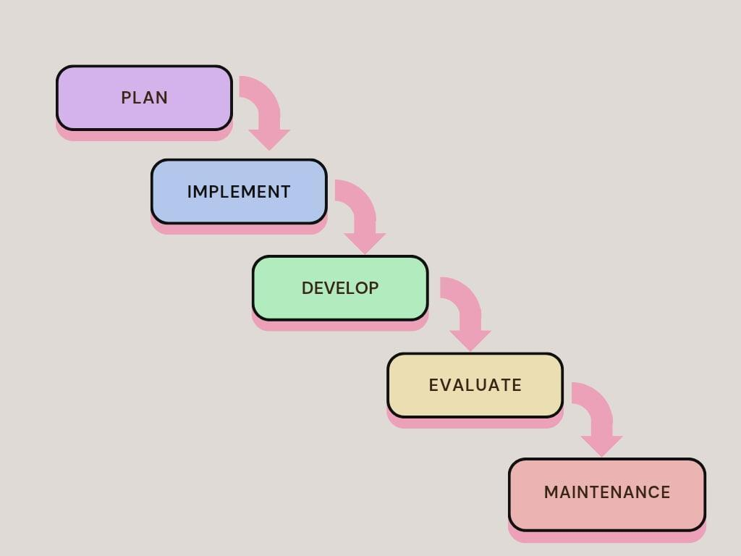
Figure 2-1. Waterfall Model.
The diagram shows the five main phases of the system development process: Plan, Develop, Implement, Evaluate and Maintainance. These phases form a continuous cycle that guides how the AI traffic monitoring system is created. In the Implement phase, the trained model is connected to the CCTV feed and the system begins detecting vehicles in real time. In the Develop phase, the system is designed and the AI model is trained. The dataset is prepared, annotated, and used to create the YOLOv5 detection. In the Evaluate phase, the system is tested for accuracy, reliability, and responsiveness. Feedback from TMC personnel is gathered to assess usability and identify improvements.

Procedures for the different phases
1. System Analysis and Requirements Gathering
- The researchers will conduct interviews and consultations with the Traffic Management Center (TMC) personnel to identify common vehicle -related violations, monitoring challenges, and operational requirements.
- The existing CCTV infrastructure of Malaybalay City will be assessed to determine camera placement, video quality, and feasibility of integrating AI-based monitoring.
- Functional and non-functional requirements will be documented, including detection accuracy, response time, system reliability, and dashboard functionalities.
2. System Design and Modeling
- A Use Case Diagram will be created to outline the interactions between the system and TMC officers, including monitoring, reviewing alerts, and accessing violation logs.
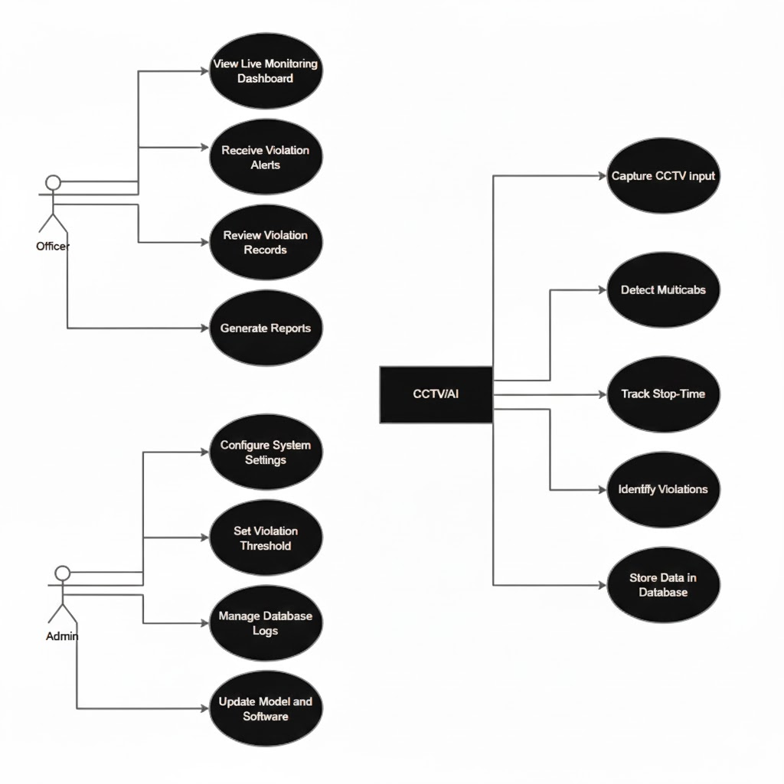
Figure 3-1. Use Case Diagram

- A Data Flow Diagram (DFD) will be developed to illustrate how video data flows from CCTV cameras to the detection module, database, and the TMC dashboard.
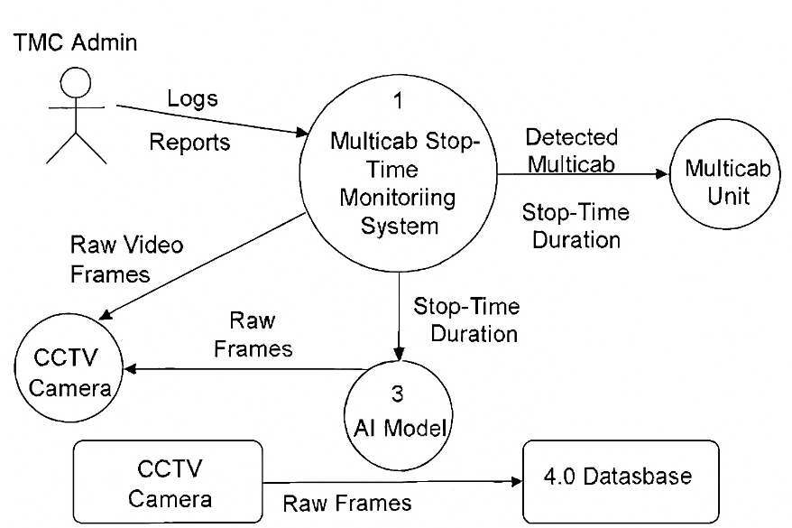
Figure 4-1. Data Flow Diagram
- A System Architecture Diagram will show how the hardware and software components—CCTV cameras, AI processing unit, backend server, and dashboard—communicate with each other.

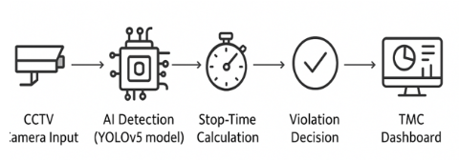
Figure 5-1. System Architecture
- A Flowchart will be designed to represent the step-by-step process from video input, vehicle detection, tracking, stop-time measurement, alert generation, and logging.
- A Database Schema will be constructed, defining tables for violations, timestamps, vehicle classifications, and user information for TMC personnel.
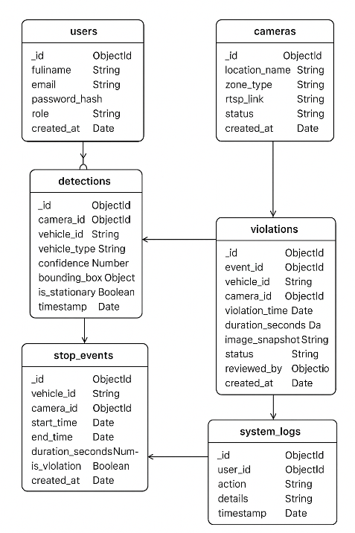
Figure 6-1. Database Schema
3. Data Preprocessing
- CCTV footage collected from target intersections will be segmented into video frames for model training and testing.
- Image preprocessing methods such as frame extraction, resizing, normalization, and noise reduction will be performed to ensure consistent image quality.
- Manual annotation of vehicle images—including vehicles, tricycles, private cars, and other classes—will be carried out using LabelImg, creating bounding box labels compatible with YOLOv5 formatting.
- The annotated dataset will be augmented (e.g., through rotation, brightness adjustment, and flipping) to increase robustness under varying lighting and environmental conditions.
4. Model Training and System Implementation
- An existing YOLOv5 model will be trained and fine-tuned using PyTorch on Google Colab with GPU acceleration for vehicle detection in Malaybalay City.
- Hyperparameters such as batch size, learning rate, image size, and epochs will be optimized based on validation accuracy.
- The model’s performance will be evaluated using metrics such as Precision, Recall, F1-score, and mAP (mean Average Precision).
- Tracking algorithms (e.g., DeepSORT or ByteTrack) will be integrated to maintain consistent object identity across consecutive frames, allowing precise measurement of stop durations.
- A stop-time computation module will be developed to determine when a vehicle stops inside the yellow box, and for how long.
5. System Integration and Implementation
- A backend service using Node.js will be developed to handle data storage, API communication, and dashboard updates.
- A MongoDB database will store detection results, timestamps, images, and violation
- A web-based logs.dashboard will be built using React, enabling TMC officers to:
  - view real-time CCTV feeds with detection overlays,
  - review logged violations,
  - access historical data,
  - generate reports for enforcement.
- The detection model will be integrated with the live CCTV feed for real-time inference using OpenCV video streaming.
- To optimize monitoring efficiency, the system will record vehicle activity according to a defined time schedule. High-traffic periods during peak hours (6:00–9:00 AM and 4:00–7:00 PM) will be prioritized for real-time violation detection, while off-peak periods (10:00 AM–3:00 PM) will be recorded intermittently for trend analysis. The schedule can be adjusted based on the Traffic Management Center’s (TMC) operational needs and observed traffic patterns.

Violation Documentation and Serving Procedure (NCAP-Based Reference)
The proposed system adopts a no-contact violation documentation approach, guided by the principles of the No Contact Apprehension Policy (NCAP) implemented by the Metropolitan Manila Development Authority (MMDA). In this approach, traffic violations are detected and documented without direct interaction between traffic enforcers and drivers.
When the system detects a vehicle stopping beyond the allowable time within a yellow box zone, it automatically records timestamped visual evidence, including video frames, stop duration, location, and vehicle classification. These records are stored in the system database and transmitted to the Traffic Management Center (TMC) dashboard for review.
Authorized TMC personnel are responsible for verifying each detected violation to ensure accuracy and validity before any enforcement action is taken. The system does not automatically issue penalties; instead, it functions as a decision-support tool that provides objective evidence for traffic authorities.
Serving of violations, such as the issuance of notices or citations, is handled by the appropriate local government unit following existing traffic enforcement procedures of Malaybalay City. The AI-based system supports this process by supplying verified digital records consistent with NCAP-based enforcement principles.

Handling Multiple vehicles in Real Time
The system employs a multi-object tracking algorithm (YOLO) to uniquely identify and track each vehicle as it enters the monitored yellow box zone. Each vehicle is assigned a unique ID, which allows the system to:
- Record the exact arrival time of each vehicle.
- Track its stop duration within the yellow box zone independently.
- Generate separate violation records if a vehicle exceeds the allowable stop time.
- Ensure that multiple vehicles arriving at overlapping times do not interfere with each other’s tracking or stop-time computation.
All recorded data, including vehicle ID, timestamp, stop duration, and violation status, are stored in the database and displayed in the TMC dashboard for review and enforcement actions.

Evaluation
The evaluation process focused on studying the Vehicle Yellow Box Zone Monitoring System’s overall functionality, usability, and reliability. This phase aimed to determine how effectively the system monitored vehicle activity, generated real-time alerts, and supported traffic management operations. Selected personnel from the Traffic Management Center (TMC) of Malaybalay City, who represent the system’s primary users, participated in the evaluation process.
User feedback was collected using a standard evaluation form based on three categories: Functionality, Usability, and Reliability. Each category included multiple statements rated on a five-point Likert scale, where 5 = Strongly Agree, 4 = Agree, 3 = Neutral, 2 = Disagree, and 1 = Strongly Disagree.

Functionality | 5 | 4 | 3 | 2 | 1
The system delivers accurate detection of vehicles and stop-time measurements.
The system processes video input and generates reports accurately.
The system correctly identifies and distinguishes multiple vehicles arriving at different times.
The system incorporates automated violation alerts with timestamped evidence.
The system appropriately displays real-time data and dashboards for TMC officers.

Usability | 5 | 4 | 3 | 2 | 1
I would consider using this system frequently in my traffic monitoring tasks.
The system’s functions are well-integrated and easy to navigate.
I feel confident navigating and using the system interface.
Users would be able to learn how to operate the system quickly.
The system appears unnecessarily complex in certain areas.

Reliability | 5 | 4 | 3 | 2 | 1
The system operates reliably under normal and peak traffic conditions.
All system processes function without errors or interruptions.
The system consistently generates accurate and dependable reports.
The system provides information consistently and without data loss.
The system maintains performance under varying environmental conditions (rain, night-time, occlusion).

1. System Testing and Evaluation
- Unit testing will be performed for each software component (detection, tracking, backend, dashboard).
- Integration testing will ensure that the detection output, database operations, and dashboard visualization work seamlessly.
- Field testing will be conducted using actual CCTV footage from Malaybalay intersections to assess real-world performance.
- The system will be evaluated based on:
  - Detection Accuracy
  - Stop-Time Measurement Accuracy
  - Processing Speed (FPS / latency)
  - Reliability under environmental variations (rain, night-time, occlusion)
- Feedback will be gathered from TMC officers regarding usability, clarity of alerts, and overall system effectiveness.
2. Deployment and Documentation
- The final AI model and dashboard will be deployed on the designated TMC workstation.
- User manuals and technical documentation will be created for:
- system operation,
- dashboard usage,
- database maintenance, and
- troubleshooting common issues.
- A final evaluation report will be created to summarize the system’s performance and alignment with the study’s objectives.

References
(Ganapathy & Ajmera, 2024) – An Intelligent Video Surveillance System for Detecting the Vehicles On Road Using Refined YOLOV4:
https://www.sciencedirect.com/science/article/abs/pii/S0045790623004603
(Ashraf et al., 2023) - HVD-Net: A Hybrid Vehicle Detection Network for Vision-Based Vehicle Tracking and Speed Estimation:
https://www.sciencedirect.com/science/article/pii/S1319157823002112
(Ness, 2025) - Vehicle detection and recognition approach in smart surveillance system: A comparative analysis:
https://www.sciencedirect.com/science/article/pii/S2590005625001006
(Pramanik et al., 2021) - A real-time video surveillance system for traffic pre-events detection:
https://www.sciencedirect.com/science/article/abs/pii/S0001457521000506
(Ciampi et al., 2022) Multi-camera vehicle counting using edge-AI:
https://www.sciencedirect.com/science/article/abs/pii/S095741742201171X
(Trivedi et al., 2022) - Vision-based real-time vehicle detection and vehicle speed measurement using morphology and binary logical operation:
https://www.sciencedirect.com/science/article/abs/pii/S2452414X21000777
(Tan & Kieu, 2023) - TRAMON: An automated traffic monitoring system for high density, mixed and lane-free traffic:
https://www.sciencedirect.com/science/article/pii/S0386111223000444
(Wan et al., 2022) - Edge computing enabled video segmentation for real-time traffic monitoring in internet of vehicles:
https://www.sciencedirect.com/science/article/abs/pii/S0031320321003332
(Yang et al., 2023) - Cooperative multi-camera vehicle tracking and traffic surveillance with edge artificial intelligence and representation learning:
https://www.sciencedirect.com/science/article/abs/pii/S0968090X22003953
(Li et al., 2024) - Multi-level traffic-responsive tilt camera surveillance through predictive correlated online learning:
https://www.sciencedirect.com/science/article/abs/pii/S0968090X24003255
(Gupta et al., 2023) - Real-time traffic control and monitoring:
https://www.sciencedirect.com/science/article/pii/S2772671123001067
(Rezaei et al., 2023) - 3D-Net: Monocular 3D object recognition for traffic monitoring:
https://www.sciencedirect.com/science/article/pii/S0957417423007558
(Bhavsar et al., 2023) - Vision-based investigation of road traffic and violations at urban roundabout in India using UAV video: A case study:
https://www.sciencedirect.com/science/article/pii/S2666691X23000477
(Nocua M et al., 2025) - Urban traffic monitoring based on deep learning on an embedded GPU:
https://www.sciencedirect.com/science/article/pii/S0957417425004695
(Rathore et al., 2021) - Smart traffic control: Identifying driving-violations using fog devices with vehicular cameras in smart cities:
https://www.sciencedirect.com/science/article/abs/pii/S2210670721002729
(Valdivieso Tituana et al., 2022) - Vehicle Counting using Computer Vision: A Survey:
https://ieeexplore.ieee.org/document/9824432
(Rezaei et al., 2022) - 3D-Net: Monocular 3D object recognition for traffic monitoring:
https://www.sciencedirect.com/science/article/pii/S0957417423007558

